Chapter 3 Equilibrium of forces
Chapter Test Answers Total marks 42
Question 1
At a building site, a pulley system operated by an electric motor is used to lift bricks to the upper floors of the building. The motor can supply a torque of 750 N m. The pulley operated by the motor has a radius of 18 cm. The diagram below shows the system.

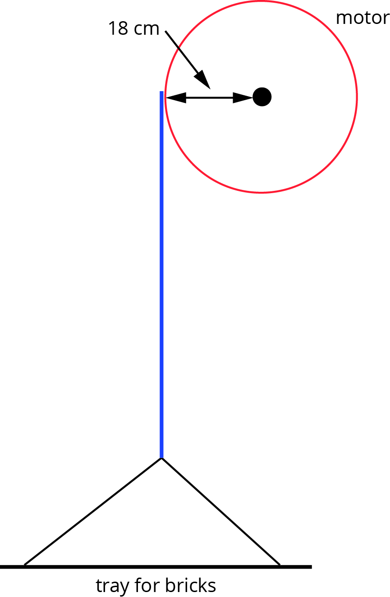

What is the maximum mass of bricks the winch can lift? (3 marks)

Description | Marks
τ = rF | 1
 | 1
 | 1
Question 2
You are working as a designer of home plumbing fittings and are asked to design a tap that is easy to turn for people with conditions such as arthritis or older people with less strength in their arms. Sketch a labelled diagram of your tap design below and explain the physics principles in your design that will make it easy to turn. (3 marks)

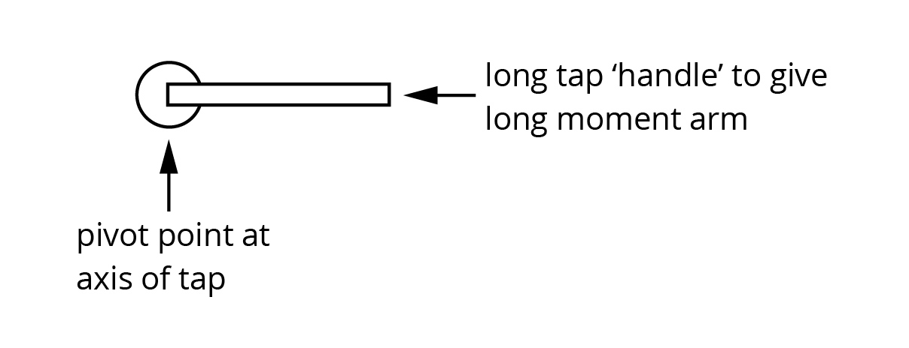

Description | Marks
Labelled diagram | 1
Design has long moment arm | 1
Recognition that long moment arm will increase torque around tap without increasing force that needs to be applied to tap (as an application of τ = rF ) | 1

Question 3
The diagrams below show designs for two vases. The centre of mass, G, is marked on each.

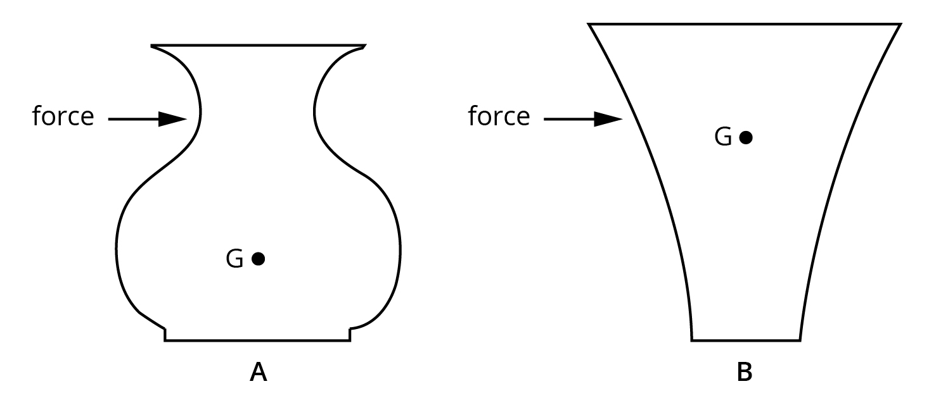

State which of the two vases is more stable. Using the appropriate physics principles, explain your answer. In your answer give the reason the less stable vase will tip over. Sketch labelled lines on the diagrams to illustrate your answer. (4 marks)

Description | Marks
Vase A is more stable. | 1
For B, the distance through which it must travel to reach the point when G is outside the base is less than it is for A. | 1
At the point where G is outside the base, there is a clockwise moment about the pivot which will cause the vase to tip over. | 1
Appropriately labelled lines | 1

Question 4
Large tower cranes such as the one shown below are often seen on construction sites. They do not have a single load limit but rather have a table giving the maximum load for each metre of distance the load is along the jib.
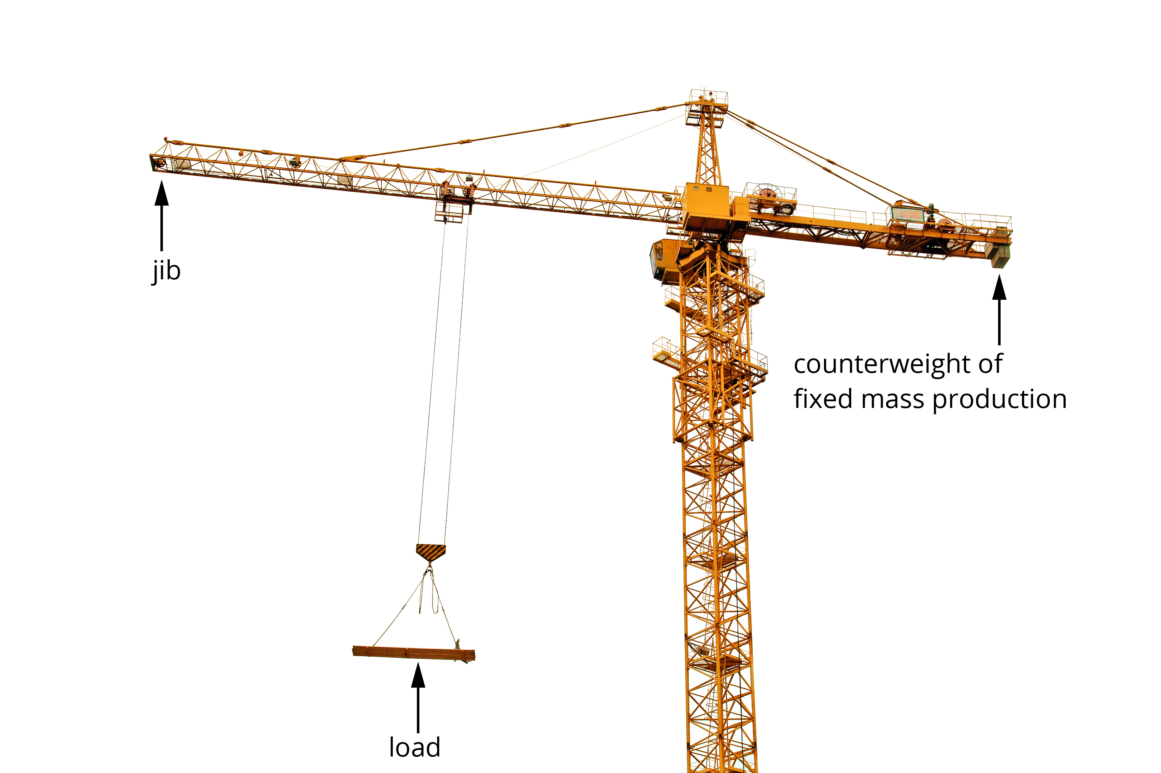

If you determine the product of the load and distance along the jib in each case, what would you expect the result to be? Explain your answer. (3 marks)

Description | Marks
The product of load and distance along the jib will be the same in each case. | 1
The load on the jib arm is balanced by the counterweight (the value will equal the product of the counterweight of fixed mass and position). | 1
This is necessary for the anticlockwise and clockwise moments to be equal (to achieve rotational equilibrium). | 1

Question 5
The French theatre company Royal de Luxe uses giant puppets for street art. One of the giants, a diver, is 9.5 m tall and has a mass of 2.5 tonnes (1 tonne = 1000 kg). The giant is made to ‘walk’ by a series of pulleys attached to the arm of a crane overhead and operated by the weight of two people pulling on a pulley rope to lift the legs.
Examine the diagram below to make an estimate of the tension needed in the rope to hold the upper leg (thigh) at the point indicated in the picture. A simplified line drawing of the head, torso and one leg is shown to assist. Clearly indicate the values you use to determine your estimate of the tension in the rope. The line drawing can be drawn on to assist in determining estimates. (10 marks)

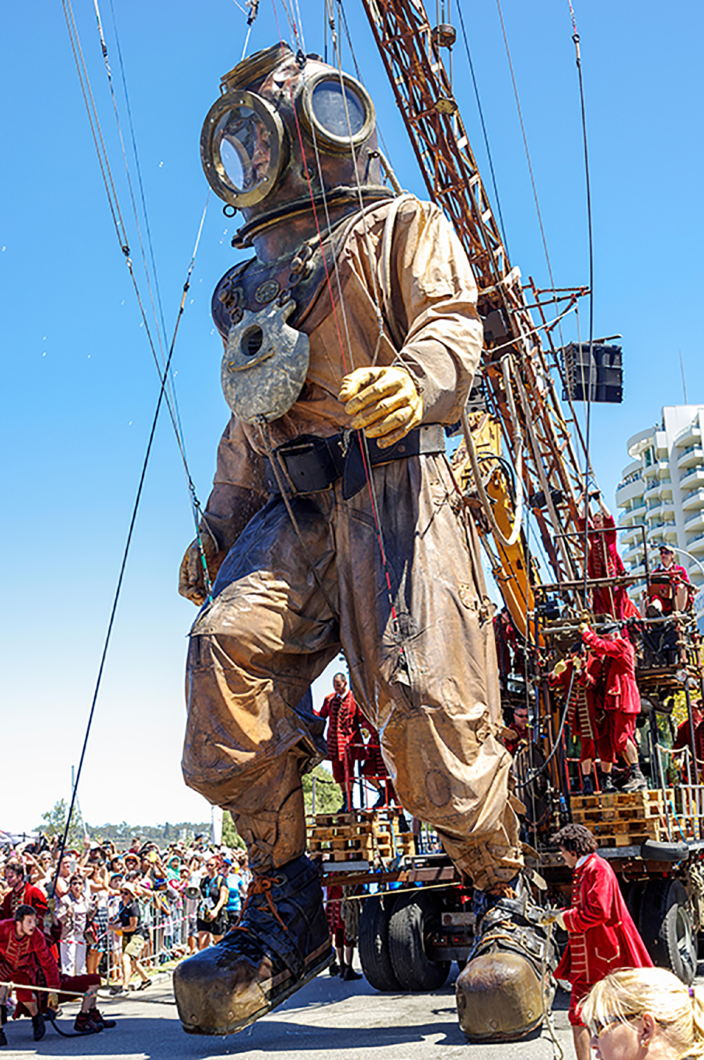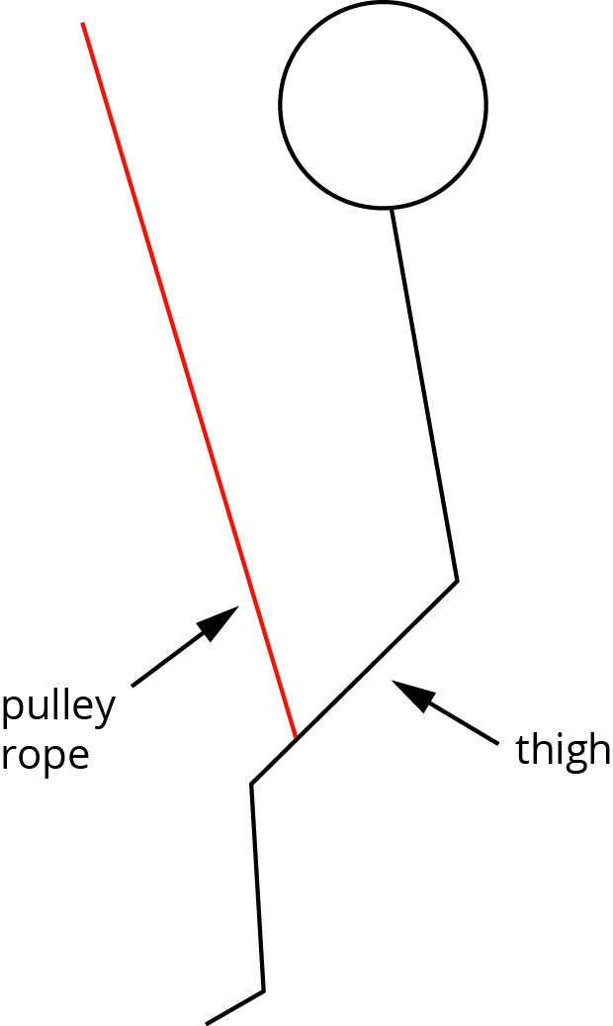

Description | Marks
Recognition of pivot point at hip | 1
Estimates include:  - mass of thigh ~250 kg  - mass of lower leg and foot ~200 kg  - single rope makes with thigh ~75°  - length of cm arm ~3 m  - length of acm arm for centre of mass of thigh ~2 m  - length of acm arm for lower leg ~4 m  - angle lower leg makes with thigh ~40°  Note: Accept any reasonable estimates. | 1−3
For clockwise moments: | 1  1
For anticlockwise moments  For thigh:  For lower leg:  Σ acm = 1.6 × 10³ × 2 + 1.3 × 10³ × 4 = 8.2 × 10³ N m | 1  1  1
Σ cm = Σ acm  F_{rope} × 2.9 = 8.2 × 10³  i.e. F_{rope} = 1.85 × 10³  Thus, tension in rope is approximately 2.8 × 10³ N.  Note: The final answer will depend on the estimates above. | 1

Question 6
While watching a bobcat moving large concrete pipes, Adrian notices that when attempting to lift one large pipe positioned near the end of the forks furthest from the machine, the rear of the bobcat lifts off the ground. The operator then jiggles the pipe closer to the machine. The pipe is then successfully lifted. Explain these observations using the appropriate physics concepts. The diagram can be annotated to assist your explanation if you wish. (3 marks)

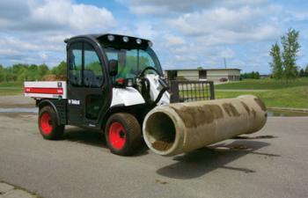
Source: © Jim Parkin/Alamy
Description | Marks
(Assuming front wheels on right of diagram)  Recognition that when pipe is at end of forks, the clockwise moments are greater than the anticlockwise moments thus bobcat pivots about front wheels. | 1
Moving the pipe towards machine reduces the length of the clockwise moment arm. | 1
Shorter clockwise moment arm leads to clockwise moments becoming less than the anticlockwise moments. | 1

Question 7
A bed consists of a uniform support base for the mattress, the bedhead and the end of the bed. The support base slots into metal supports on the bedhead and end of the bed, as shown in the diagram below. The bed has a length of 2.00 m, a uniform 20.00 kg mattress and the base has a mass of 50.00 kg.

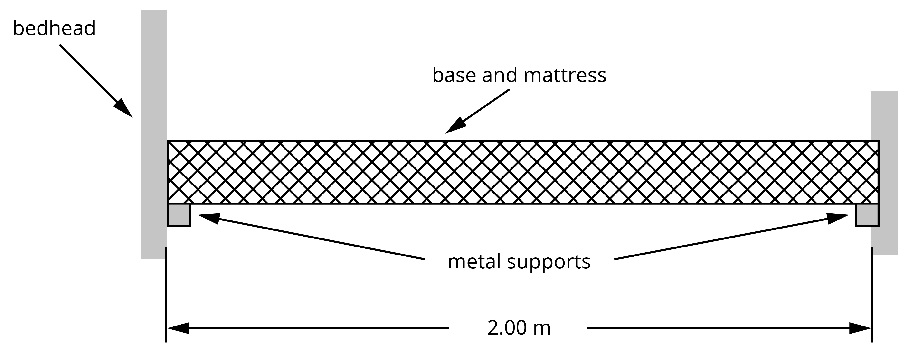

- If the centre of mass of a 65.0 kg person sleeping in the bed is 30.0 cm from the bed’s centre of mass, calculate the force provided by the metal support at the bedhead. Give your answer to the correct number of significant figures. (5 marks)

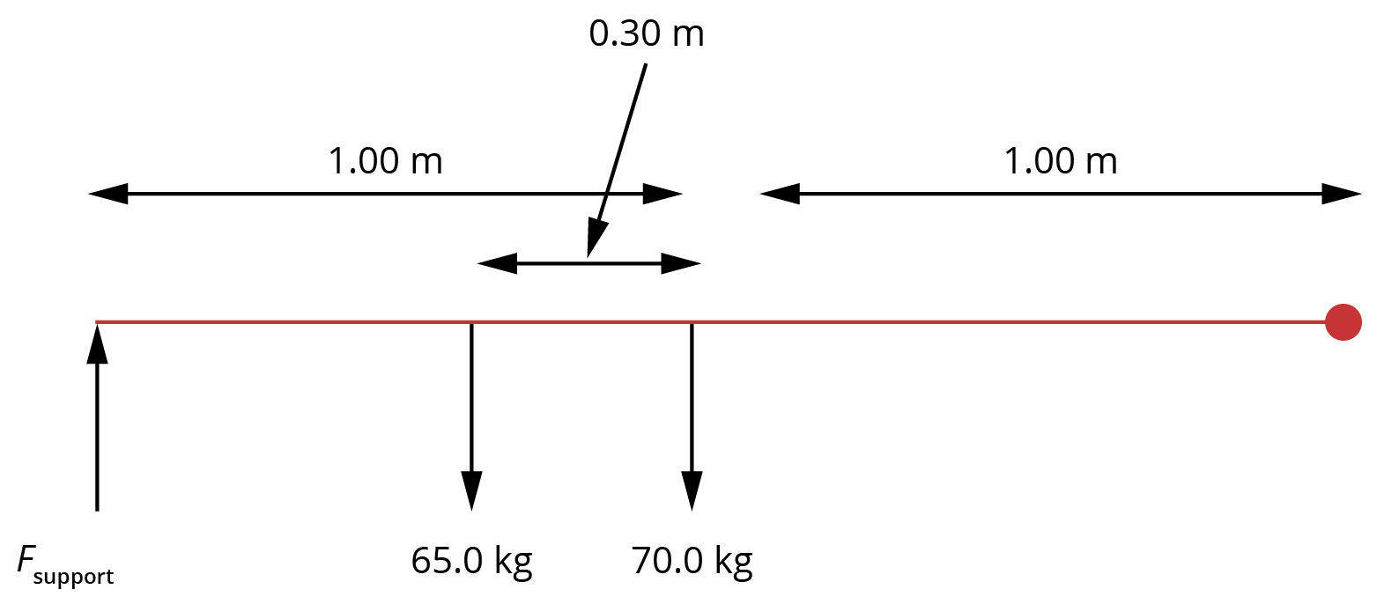

Description | Marks
Sum of clockwise moments = sum of anticlockwise moments | 1
Recognition of pivot | 1
 | 1
 | 1
Answer to 3 significant figures | 1

- What is the force provided by the support at the end of the bed when the 65.0 kg person is sleeping in the bed? (3 marks)

Description | Marks
sum of forces up = sum of forces down | 1
757 + F_{end} = (65 + 70) × 9.8 | 1
F_{end} = 1323 – 757 = 566 N up | 1

Question 8
A 75 kg sign is suspended from a uniform 8.5 kg wooden beam of length 2.2 m. The sign is 1.8 m from the wall and a steel cable is attached to the beam 1.5 m from the wall at an angle of 45°.

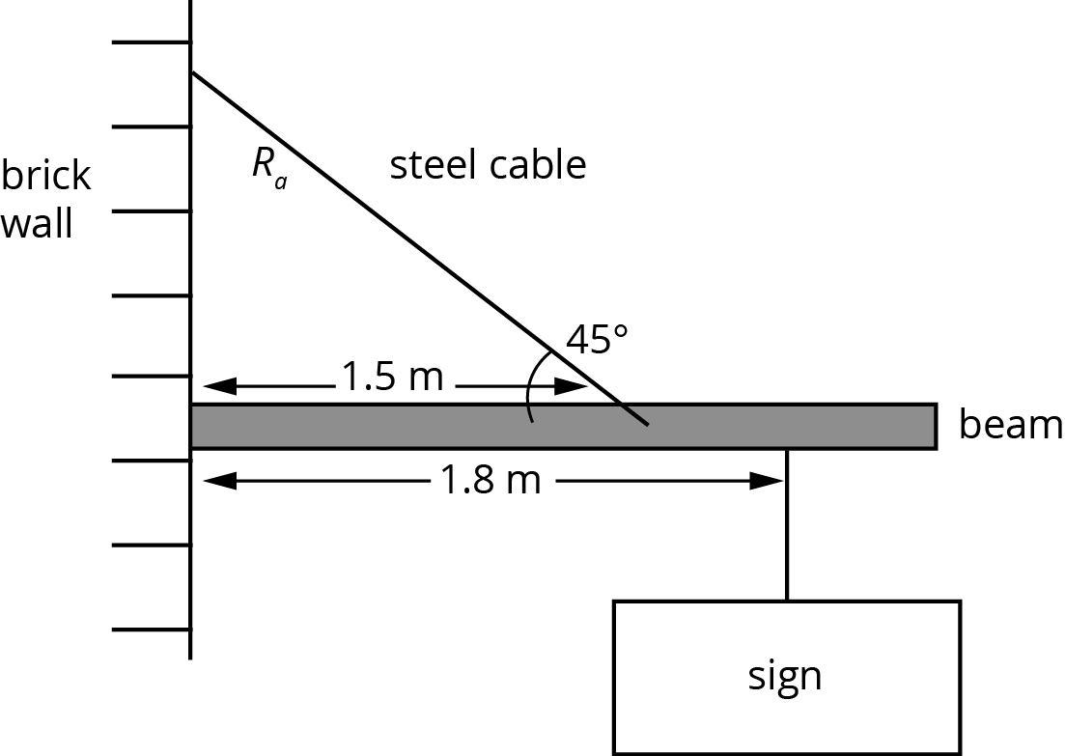

- State the conditions needed for this structure to be in equilibrium. (2 marks)

Description | Marks
sum of forces up = sum of forces down | 1
sum of clockwise moments = sum of anticlockwise moments | 1

- Determine the tension in the steel cable. (6 marks)

Description | Marks
Recognition of pivot point | 1
sum of anticlockwise moments from steel cable = sum of clockwise moments due to weight of beam and sign | 1
R_{a} = 1.5 sin 45 = 1.06 m | 1
TR_{a} = m_{beam}gr_{beam} + m_{sign}gr_{sign} | 1  2

